Conservative Animal Welfare Foundation letter to the Prime Minister urges for a ban on the UK ivory trade

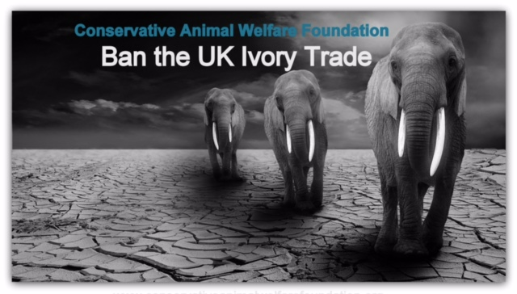
Conservative Animal Welfare Foundation calls for greater protection for elephants which are being decimated for the ivory trade.
Conservative MPs, as well as the Chairmen of the Conservative Women's Organisation and Conservative Environment Network join together in the Conservative Animal Welfare Foundation's letter to the Prime Minister urging for a ban on the UK ivory trade.
Populations are at an all-time low with the species facing extinction due to the ivory poaching crisis which is killing at least 20,000 elephants each year.
Lorraine Platt, Co- Founder, says:
"It's important to remember that ivory represents a dead elephant. We have to protect elephants now for the sake of future generations as time is running out for vulnerable elephants whose populations are being decimated on an unprecedented scale. We need to end the UK’s ivory market and save the iconic elephant from the threat of extinction.
Defra is expected to announce a consultation on a UK ivory ban in the near future. We urge for this to take place as soon as possible along with an end to the UK ivory trade."
www.conservativeanimalwelfarefoundation.org
Please contact Lorraine Platt on 07554 585555
www.conservativeanimalwelfarefoundation.org

=

